Gundam Class Design Document

Aubrey D. Soule
IT, Software Development and Coding, ECPI University
SDC330: Advanced Programming Using Java
Dr. Helio Castro
April 19, 2026

Gundam Rolodex – Class Design Document

What classes will you create?
The application will include the following classes:
- App
- Gundam
- CombatGundam
- Manufacturer
- (Optional) Displayable interface
These classes help organize the program and separate different responsibilities.

Class name & Purpose
App
Main class that runs the program and handles user interaction (menu, input, output).
Gundam
Base class that stores general Gundam information such as name, model number, and pilot.
CombatGundam
Derived class that adds combat-related details like type and weapon.
Manufacturer
Represents the company or organization that creates the Gundam.
Displayable (Interface)
Defines a method for displaying information in a consistent format.

Who’s teaching this class?
The class structure is designed by the student based on concepts taught in the course lectures and examples provided by the instructor.

What logically demonstrates inheritance?
Inheritance is shown by CombatGundam extending Gundam, meaning it inherits the base properties and adds more features.

What’s the base class?
The base class is Gundam.

What functionality is shared among the derived classes?
All Gundams share:
- Name
- Model Number
- Pilot
This common data is stored in the base class.

What derived classes do you need?
- CombatGundam
(Additional types could be added later if needed.)

What unique characteristics do the derived classes provide?
CombatGundam includes:
- Type (Assault, Sniper, etc.)
- Weapon
These are not part of the base class.

Who’s receiving the inheritance and how much are we talking about?
CombatGundam receives all properties and methods from Gundam, including name, model number, pilot, and the toString method, and then extends it with additional fields.

What logically demonstrates composition?
Composition is demonstrated by a Gundam having a Manufacturer.

What needs to be used together?
- Gundam and Manufacturer
Every Gundam is associated with a manufacturer, so they are naturally used together.

Is there an opportunity to use polymorphism?
Yes, polymorphism can be used when displaying Gundam objects using a common method like toString() or a shared interface method.

What can be abstracted into an interface?
A Displayable interface can be created.

What functionality will the interface define?
A method like:
- displayInfo()
This ensures all classes display information in a consistent way.

Why does it make sense for this to be an interface?
Because multiple classes may need to display their data differently but still follow the same structure.

What functionality will each class/interface provide?
- App → Controls program flow and user interaction
- Gundam → Stores basic Gundam data
- CombatGundam → Adds combat-specific features
- Manufacturer → Stores manufacturer details
- Displayable → Ensures consistent display behavior

Where is polymorphism demonstrated?
Polymorphism is demonstrated when different objects (like Gundam and CombatGundam) are treated the same way but display their data differently using overridden methods.

How do all the classes fit together?
All classes work together to form a modular system:
- The App class controls everything
- Gundam and CombatGundam store and organize data
- Manufacturer adds additional detail through composition
- The optional interface ensures consistency
This structure makes the program organized, reusable, and easy to expand.

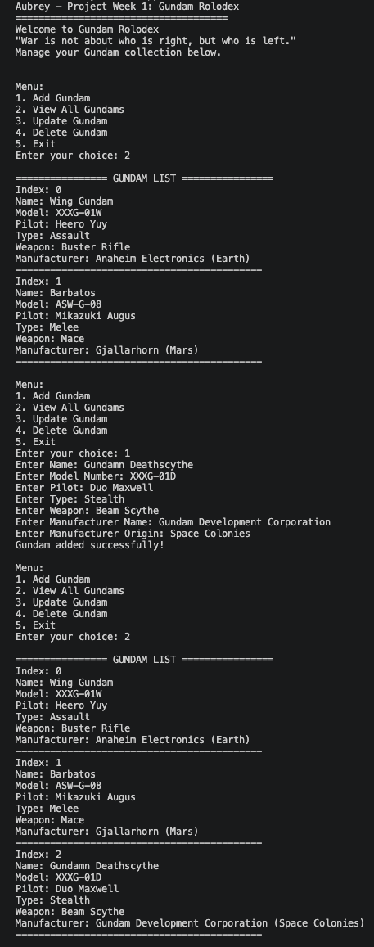
References

